Junit Advanced Testing
1.Parameterized Tests
EvenChecker.java
public class EvenChecker {
public boolean isEven(int number) {
return number % 2 == 0;
}
}

EvenChecker.java
import org.junit.jupiter.params.ParameterizedTest;
import org.junit.jupiter.params.provider.ValueSource;
import static org.junit.jupiter.api.Assertions.assertTrue;
import static org.junit.jupiter.api.Assertions.assertFalse;
public class EvenCheckerTest {
EvenChecker checker = new EvenChecker();
@ParameterizedTest
@ValueSource(ints = {2, 4, 6, 8, 10})
void testIsEvenWithEvenNumbers(int number) {
assertTrue(checker.isEven(number));
}
@ParameterizedTest
@ValueSource(ints = {1, 3, 5, 7, 9})
void testIsEvenWithOddNumbers(int number)
{
assertFalse(checker.isEven(number));
}
}
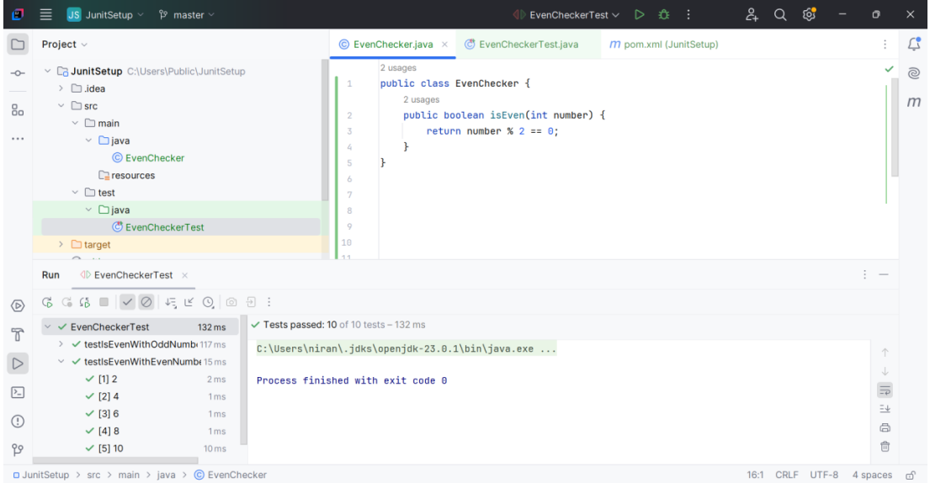

2.Testsuites and Categories

AllTests.java
import org.junit.platform.suite.api.SelectClasses;
import org.junit.platform.suite.api.Suite;
@Suite
@SelectClasses({
CalculatorTest.class,
EvenCheckerTest.class
})
public class AllTests {
}
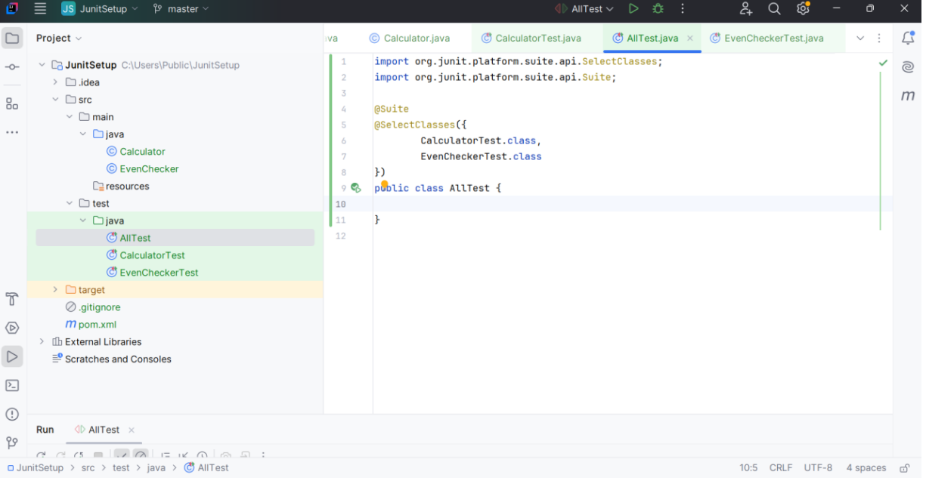

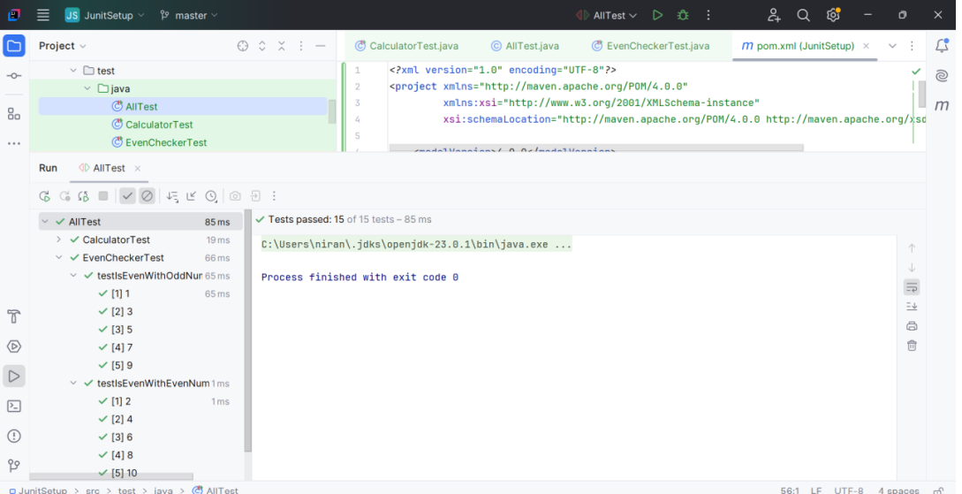

3.Test Execution Order

OrderedTests.java
import org.junit.jupiter.api.MethodOrderer.OrderAnnotation;
import org.junit.jupiter.api.Order;
import org.junit.jupiter.api.Test;
import org.junit.jupiter.api.TestMethodOrder;

import static org.junit.jupiter.api.Assertions.assertTrue;

@TestMethodOrder(OrderAnnotation.class)
public class OrderedTests {

@Test
@Order(2)
void secondTest() {
System.out.println("Second test running...");
assertTrue(true);
}

@Test
@Order(1)
void firstTest() {
System.out.println("First test running...");
assertTrue(true);
}

@Test
@Order(3)
void thirdTest() {
System.out.println("Third test running...");
assertTrue(true);
}}

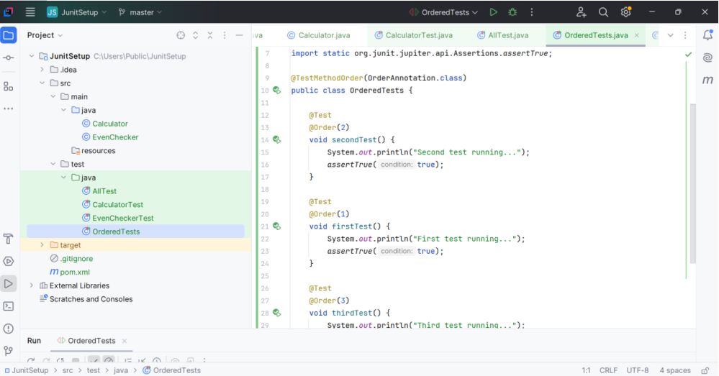

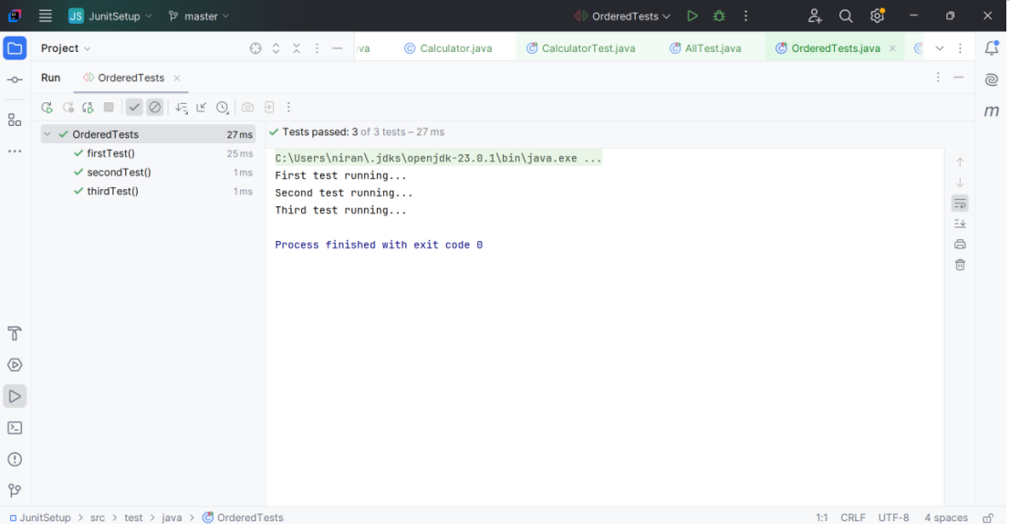

4.Exception Testing

ExceptionThrower.java
public class ExceptionThrower {

public void throwException() throws IllegalArgumentException {
throw new IllegalArgumentException("Invalid input!");
}
}
ExceptionThrowerTest.java
import org.junit.jupiter.api.Test;
import static org.junit.jupiter.api.Assertions.assertThrows;

public class ExceptionThrowerTest {
@Test
void testThrowException() {
ExceptionThrower thrower = new ExceptionThrower();

assertThrows(IllegalArgumentException.class, thrower::throwException);
}
}
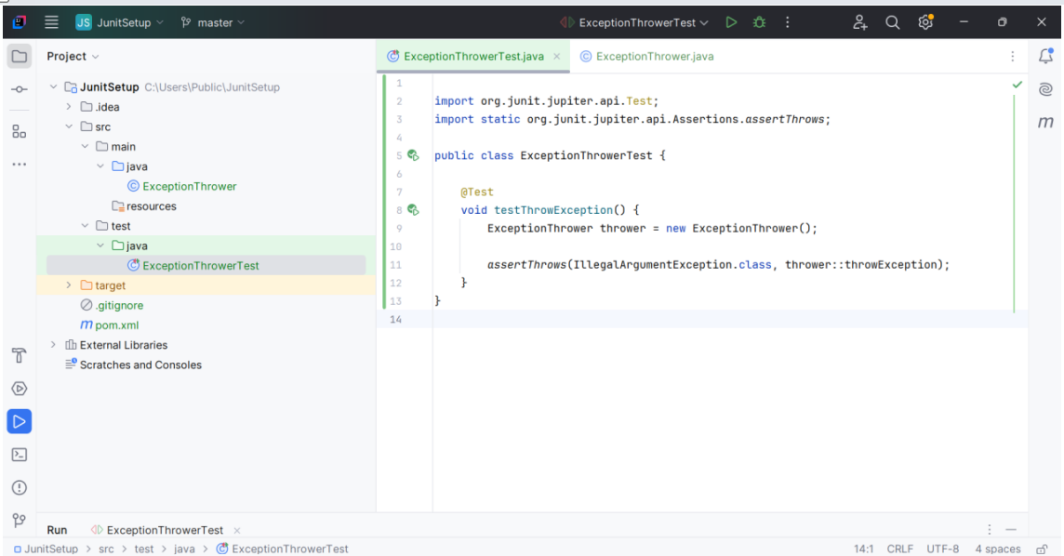
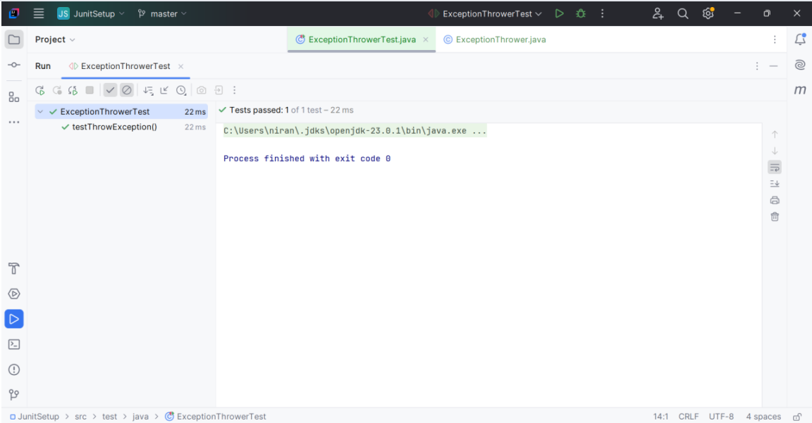
5.Timeout and Performance testing

PerformanceTester.java
public class PerformanceTester {
public void performTask() {

try {
Thread.sleep(500);
} catch (InterruptedException e) {
Thread.currentThread().interrupt();
}
}
}

PerformanceTesterTest.java
import org.junit.jupiter.api.Test;
import org.junit.jupiter.api.Timeout;
import java.util.concurrent.TimeUnit;

public class PerformanceTesterTest {

@Test
@Timeout(value = 1, unit = TimeUnit.SECONDS)

void testPerformTaskCompletesInTime()
{
PerformanceTester tester = new PerformanceTester();
tester.performTask();
}
}
